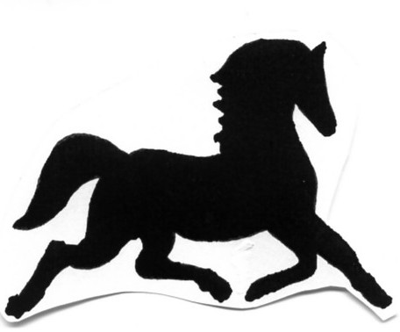HyLee Farm
2013 Summer Riding Camps
Registration Form

Please print below

Date: ___________________________

Student’s Name___________________________________________________

Birth Date/Age___________________ Sex: F_________ M_________

Current HyLee Student (circle yes or no) Yes/No

Guardians’ Names __________________________ ____________________
Primary Secondary

Address_______________________________________________________________

City_____________________________ State_________ Zip_____________

Phone (home)___________________________ Email______________________

Cell (primary)________________________Cell (secondary)________________________

Current school__________________________________________________________

If appropriate, list any Group/Family members attending with the student
______________________________________________________________________

Horse Experience _______None _______Beginner ________Intermediate________Advanced

Please describe skill level (e.g. trail riding, walk-trot-canter, showing etc.)
____________________________________________________________________________________________________________________________________________

Payment
Check Enclosed_____________

Send Completed Registration Form with Payment Enclosed to:
HyLee Farm
3460 County Road JG
Mount Horeb, WI 53572
608-437-5530
hylee@mhtc.net

Day Camp—Dates and Rate Information

Rates
- $ 80.00 Midwest Horse Fair Outing April 20th -Includes Back Pack with HyLee logo and admission to the Midwest Horse Fair. Limited to 10 attendees ($85.00 if reservation is not received by 3/29/13)

- $55.00 per day* for Day Camps in May, June, July and August
*There are no refunds given after closing date of camp deadline

Saturdays: 9 am—4 pm
- Drop-off from 8:30-9:00 am
- Pick-up from 4-4:30 pm

Please select dates from below:

_____________April 20st (Registration closes March 29th)

_____________May 18th (Registration closes May 3rd)

_____________June 8th (Registration closes May 24th)

_____________July 27^{h} (Registration closes July 12th)

_____________August 17th (Registration closes August 2nd)

*************************************************************************************

